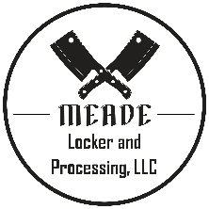

General Information
Business Hours:
Monday – Friday: 8am to 6 pm
Saturday: 9am to 1pm
Business Phone: 620-371-4056
Business Address: 152 N Post St, Meade, KS 67864
Business Email: meadelocker@gmail.com
Business Website: www.meadelocker.com

Fees (effective on animal slaughtered 1/31/2024 or after)
Slaughter/Offal Disposal Fee - $50
Processing Fee - $0.75/lb. carcass weight
Late Pick Up/Storage - $30 per week (applied after 10 days of initial contact)
Emergency Fee - $75
Single Cut Vacuum Bag – add $15
Vac Bag Ground Product – add $30
Split Bag Fee – add $45

Notes from Meade Locker
The curing process for Hams and Bacons takes 7-10 days. Please be patient as we work to get you the best possible product.

Bacon is hand cut and therefore will be thick cut. We do not offer, or have the ability to make, thin cut bacon. Please make your selections accordingly.

Smoked Bacon, Hams, and Ham Products will be labeled “Not for Sale” meaning they are able to be used by the individual processing the animal but are not able to be resold for public use.

